Lab Report

Ryan Farruggia

CSC 35

Professor Ghansah

Source code before debugging (part 1):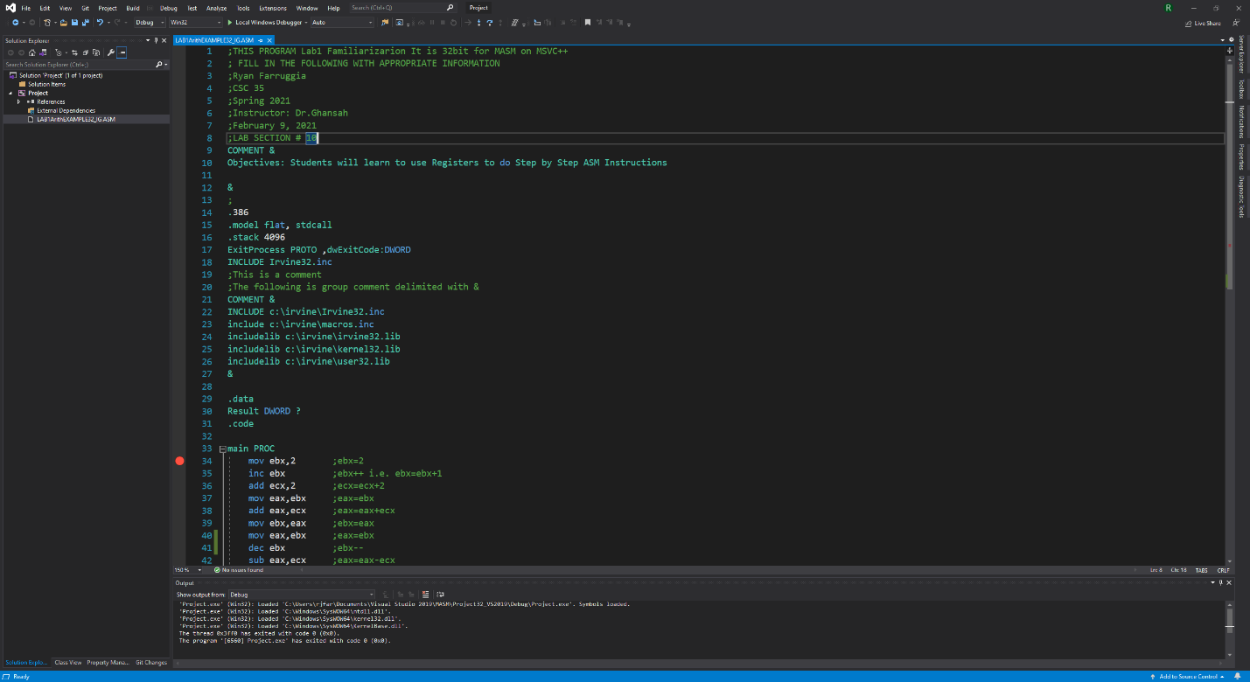

Source code before debugging (part 2):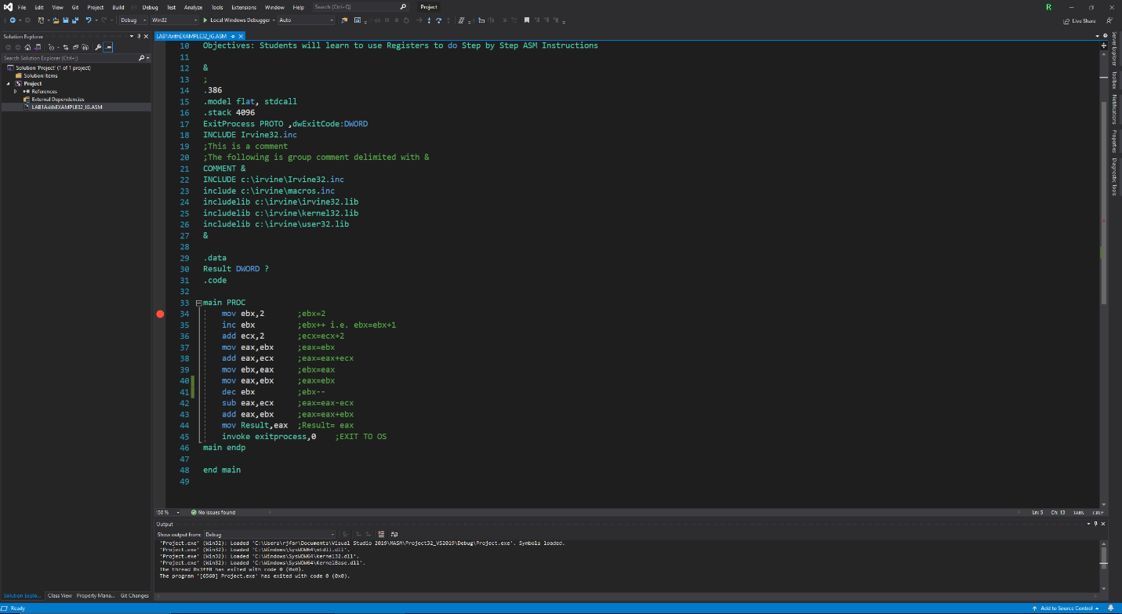

Debugging line 33 (mov ebx, 2) with registers: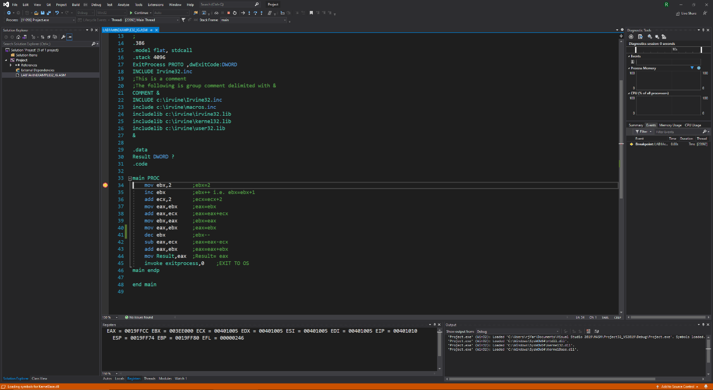

Debugging line 34 (inc ebx) with registers: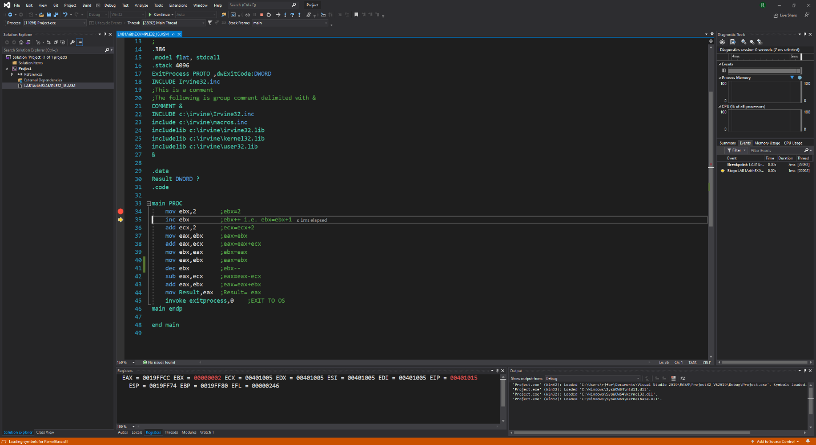

Debugging line 35 (add ecx, 2) with registers: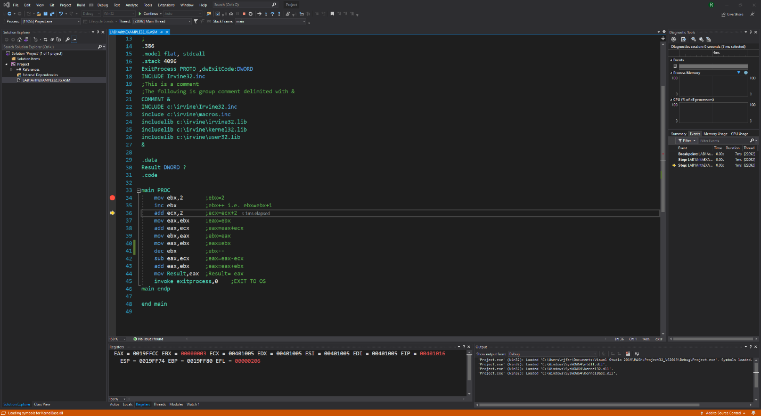

Debugging line 36 (mov eax, ebx) with registers: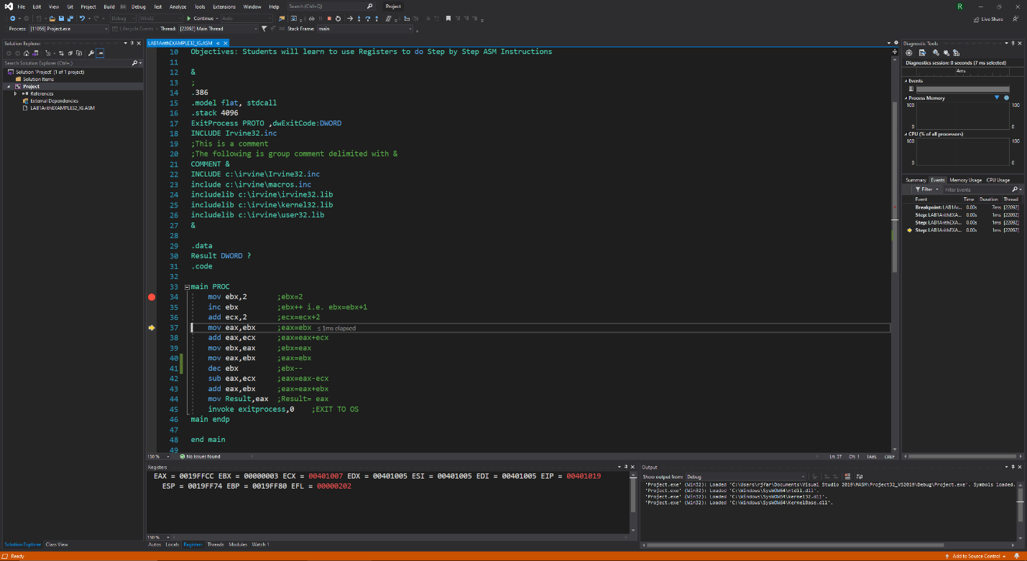

Debugging line 37 (add eax, ecx) with registers: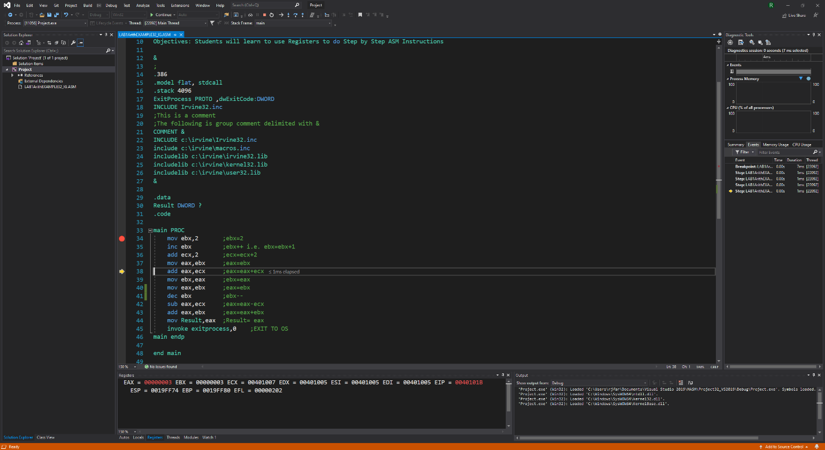

Debugging line 38 (mov eax, ebx) with registers: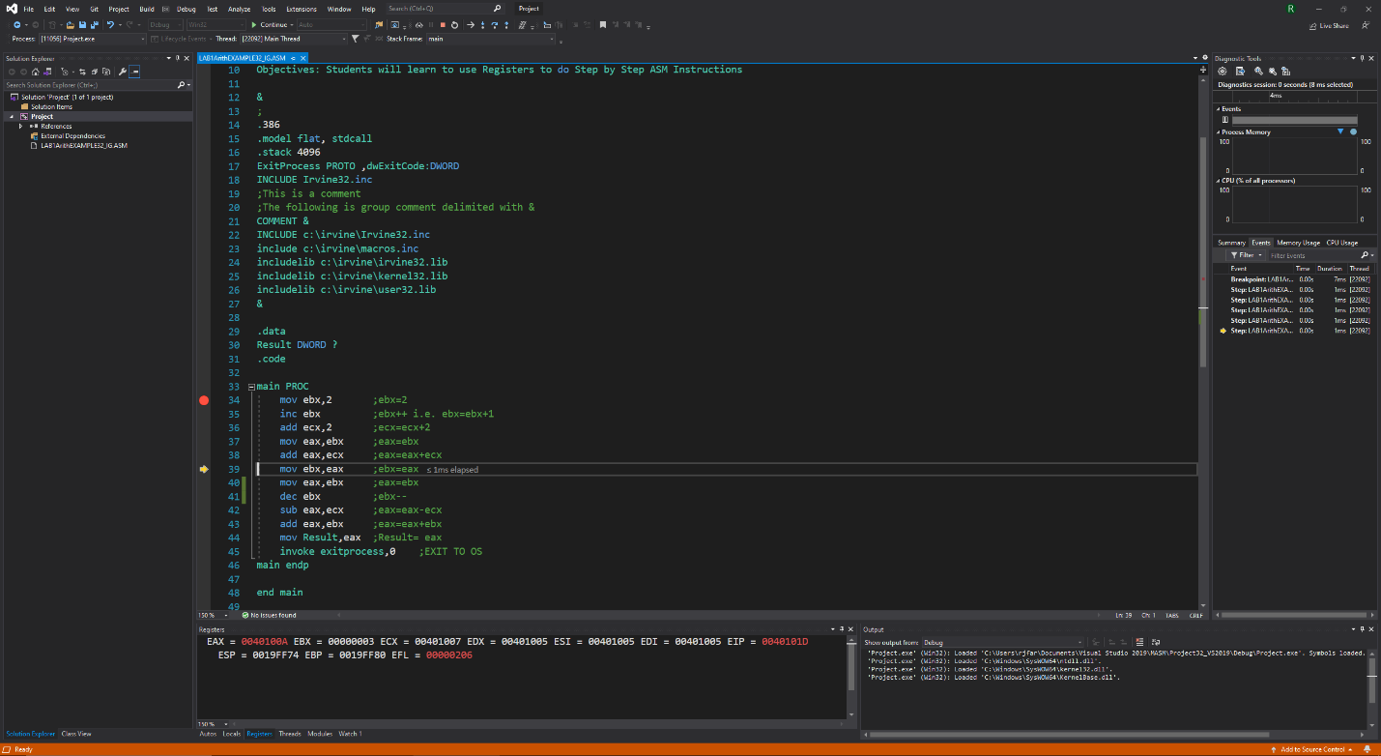

Debugging line 39 (dec ebx) with registers: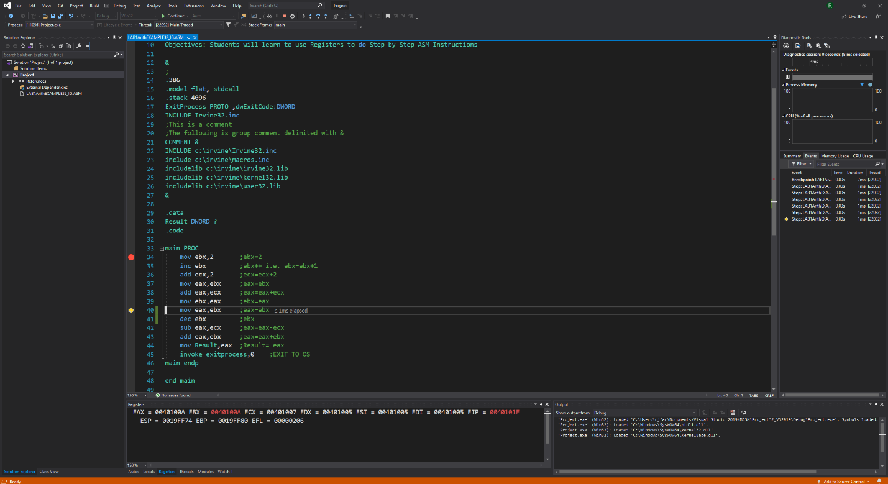

Debugging line 40 (sub eax, ecx)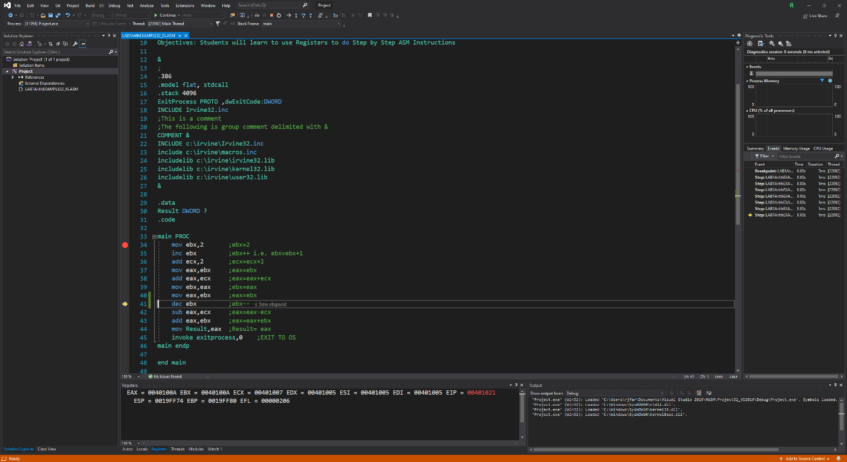

Debugging line 41 (sub eax, ecx) with registers: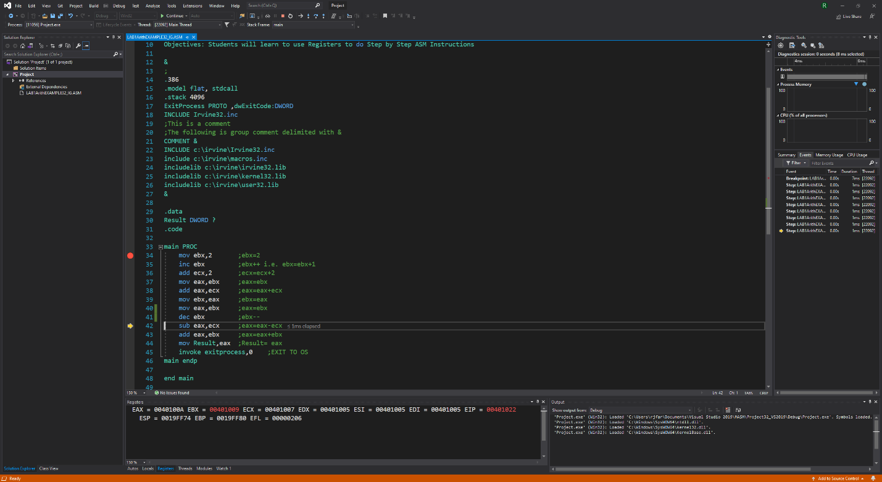

Debugging line 42 (add eax, ebx) with registers: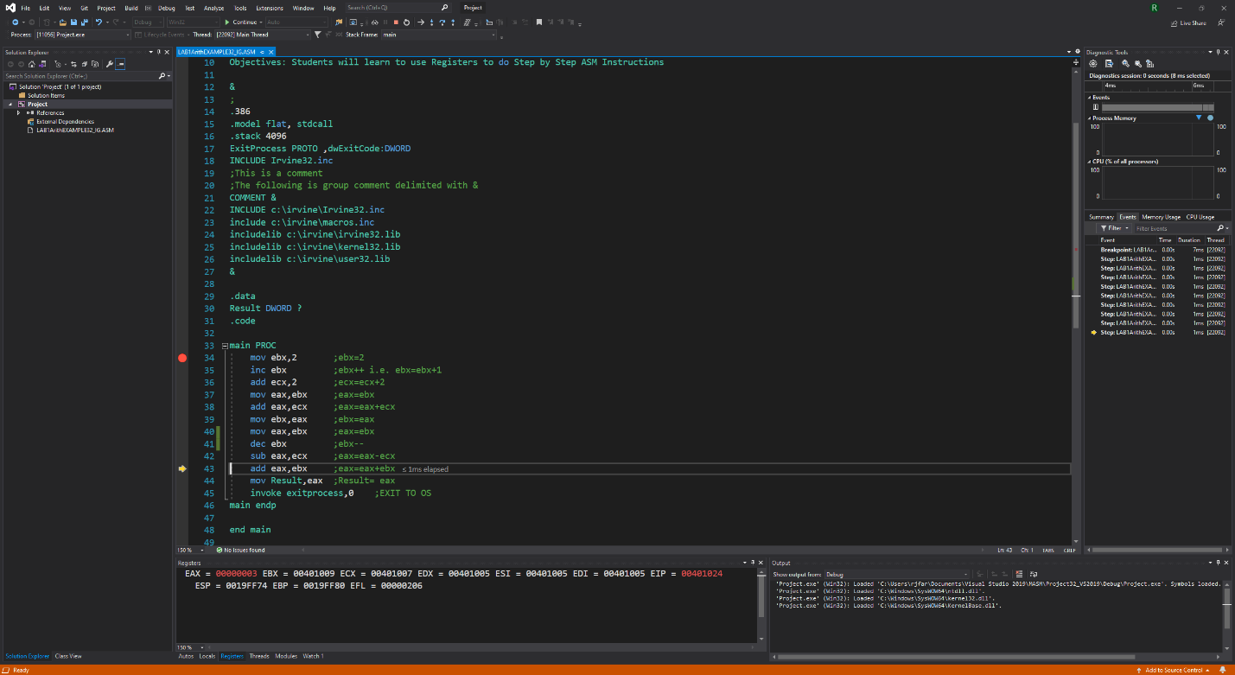

Debugging line 43 (add eax, ebx) with registers: 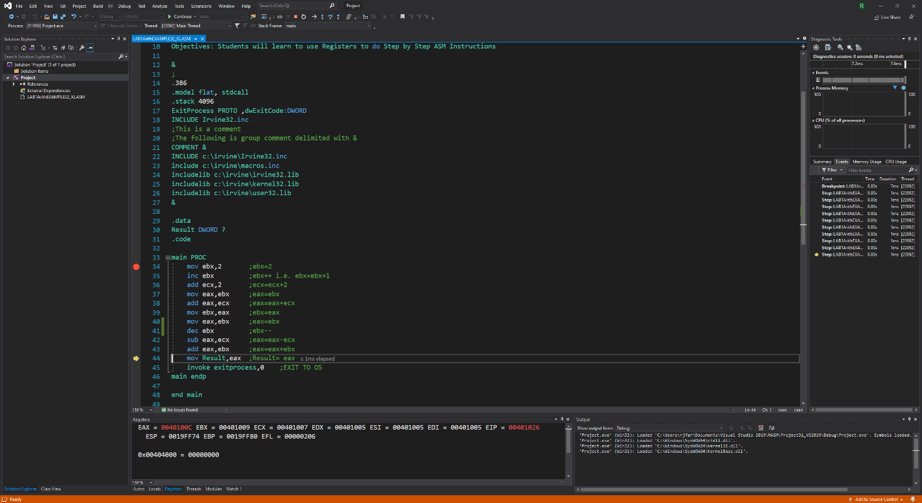

Debugging line 44 (mov Result, eax) with registers:

